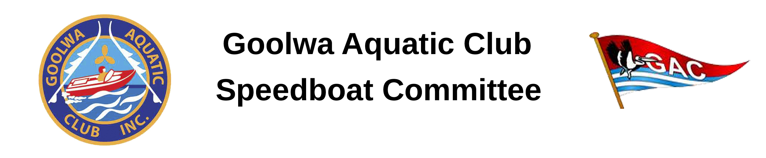
Thank you for registering to participate in Aquafest. A $60 entry fee is payable to the Goolwa Aquatic Club Speedboat Committee by posting a cheque or money order to GAC SBC, 54 Gardiner Street, GOOLWA SA 5214 or electronic funds transfer to BSB: 633-000 Account Number: 157684820 Account Name: Goolwa Aquatic Club INC Speedboats General Account, with your name in the description. As entries may be limited the earlier you pay the better your chance of being accepted however all entry fees must be paid before the 15 March 2023. Only boats whose entry fee has been received will be considered entered.
All participants must attend the Sign In Desk located at the Southern end of the clubhouse between 2:00 and 3:00 PM on Saturday or between 8:00 and 9:00 AM on Sunday prepared to sign the Participants Declaration form included in this pack. It is necessary for ALL on water participants (drivers, alternate driver and passengers) to complete a separate Participants Declaration form.
The “Officer of the Day” (OOD) will control the events and behaviour of the drivers/crews. Any instructions given by the OOD must be complied with. Failure to obey will result in cessation of participation by offender/s.
On Sunday 2 April 2023 each crew must adhere to the following:
- Attend the drivers/crew briefing at 9:00 AM sharp at the boat ramp.
- NO briefing – NO boating
- NO ALCOHOL
- Each driver must be able to present a current recreational boat driver's licence, each owner must be able to present proof of a current boat registration.
- Boat trailers and cars will be parked separately and boats launched via tractors. A crew member must be present at each launching and retrieval. Launching and retrieval is at owners risk. Boat name MUST be clearly displayed on front of trailer.
- Boats and/or crew members that are not ready for the tractor may miss their heat.
Open water Saturday, public access all areas.
Closed water Sunday, event participants only. All participants must remain inside the closed water area.
To assist you in having an enjoyable time at Aquafest we have included a suggested list of things you could check on your boat.
Please complete and tear off the bottom portion of this document and place it on your dashboard for access to the pit area.
------------------------------------------------------------------------------------------------------------------------
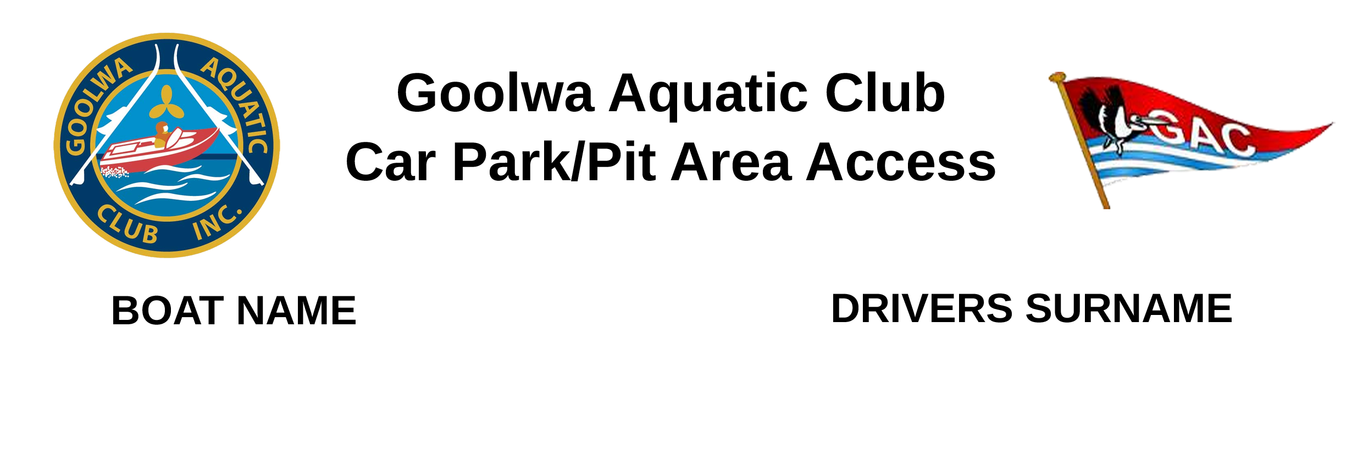
Participants Declaration covering the Goolwa Aquatic Club (Officials & Members), any promoter, any vehicle or vessel possessors or owners, crew, guarantor and/or sponsor of any event or the owner/s of the property on which the event is held, and any government, state or municipal body, community organisation, and their respective officials, agents servants or representatives, including, but not limited to, Minister for Transport and Infrastructure and the Crown in the right of the State of South Australia and their employees and agents, Alexandrina Council, Surf Life Saving SA, Volunteer Coast Guard, passengers, team owner/s and drivers.

The Goolwa Aquatic Club issues the Risk Warning pursuant to the Civil Liability Act (2002), or related legislation.

Persons wishing to participate in the Goolwa Aquatic Club event, Aquafest 2023, are advised that regardless of the precautions taken by seasoned and experienced persons, power boating can be a dangerous activity and as a participant you may be exposed to significant risk of property damage, physical harm and possibly death.

As an indication, these risks may include, but are not limited to:
- The extreme of weather and water conditions.
- The potential that control of a vessel may be lost, resulting in collision with objects and other craft, which may result in injury or death.
- The possibility that participants may be injured by equipment breaking on vessels.
- The possibility of colliding with seen or unseen objects above or beneath the surface of the water.
- The absence of immediate medical care and the likelihood that delays may occur before medical care is available.
- The possibility of being trapped in a craft or vessel.
I understand and accept the following terms and conditions of participation:
- I accept that all forms of motorsport, including power boating can be dangerous.
- I accept that as a participant or as a volunteer, I will have access to areas denied to the public, where risk of injury or death may be present.
- I have examined and made myself aware of the event venue, safety equipment, safety facilities and other aspects of the venue. I am satisfied and accept the risks that exist in this environment.
- I certify that I am physically fit, have sufficiently trained to be a participant in the event and have not been advised otherwise by a qualified medical person.
- I will attend every briefing, where my attendance has been requested by the Officer of the Day, or their representative.
- If at any time I consider the course or a section of the venue that I have entered to be unsafe, I will voluntarily withdraw from participation and ensure that my observations and opinion are conveyed to an event official as soon as practical.
- I understand that any safety equipment required under the event guidelines or relevant legislation will be carried, and that this equipment cannot guarantee my safety or the safety of my vessel, and in some circumstances may make participation more dangerous.
- I do not rely upon inspection of my/our craft and its equipment by any third party to find fault with that equipment.
- I understand and agree that safety is my own responsibility.
- I release the Goolwa Aquatic Club, its officials and members, Licence/Permit Authorities, other participants and any associated party, from all liability arising from injury or loss arising from my participation in this powerboat activity. I will advise my immediate family and heirs of this.
- Neither myself, my family, executors, administrators, next of kin, successors, representatives or heirs will take legal proceedings against the Goolwa Aquatic Club, its officials or members or other participants and any other associated party for any injury or loss I may suffer because of my participation in this powerboat activity.
- I understand that I may be giving up significant legal rights by signing this declaration and if I wish, I may obtain independent legal advice prior to signing.
- I hereby give consent to receive medical treatment which may be deemed advisable in the event of injury, accident and or illness during this event.
- I understand that at this event or related activities, I may be photographed. I agree to allow my photo, video or film likeness to be used for any legitimate purpose by the event holders, producers, sponsors, organisers and or assigned.
- The Goolwa Aquatic Club advises participants that regardless of their best intentions, safety crews may be unable to render assistance to participants who are in distress.
- Participants are further advised to consider the above risks and any other risks before deciding to participate in the activity conducted by the Goolwa Aquatic Club.
- Participants are also advised that although the Goolwa Aquatic Club is covered by third party public liability insurance, this DOES NOT extend to participants whilst on the water or working on their vessel. Any participant who considers they have a need for personal accident insurance must make their own private arrangements with an insurer.

Additional conditions for participants in craft fitted with Reinforced Cockpit/ Deflection Bar/ Restraining Belt:
I accept the possibility that as a participant I may be trapped in a craft fitted with a Reinforced Cockpit/ Deflection Bar/ Restraining Belt

I take full responsibility and use at my own risk a Reinforced Cockpit/ Deflection Bar/ Restraining Belt (delete whichever is not applicable)

DECLARATION: I have read the Risk Warning and I am aware of the risks involved in participating in the Aquafest conducted by the Goolwa Aquatic Club. I also understand in accordance with the Civil Liability Act 2002, or related legislation that my ability to seek compensation for any injury, damage or loss, sustained by myself or any persons in my care will be limited by virtue of my knowledge of any voluntary acceptance of the associated risks. By signing and providing the following information, I agree to participate in this activity and I understand and accept the risks associated with power boating as set out in this Risk Warning.

I, ___________________________________________________________________ (full name) of

_________________________________________________________________________ (address)

have read and fully understood the declaration as presented here and agree to the terms and conditions.

Signed ____________________________________________________ Date___________
For persons under the age of 18 years the following parent/guardian consent must be completed.
PARENT/GUARDIAN CONSENT – PERSONS UNDER 18 YEARS OLD
I,____________________________of (address)__________________________________________am the parent/guardian* of the above-named who is under 18 years old. I have read this document and understand its contents, including the exclusion of statutory guarantees, warning, assumption of risk, release and indemnity, and have explained the contents to the minor. I consent to the minor participating in the event at his/her own risk.
*Delete whichever does not apply.
Signed (Parent/Guardian*) ______________________________________ Date ______________
Witness Name: _______________________Witness Signature:__________________ Date:___________
ONLY TO BE WITNESSED BY A GOOLWA AQUATIC CLUB AUTHORISED REPRESENTATIVE. In signing this document as a witness, I have ensured that the signatory has agreed to participate or be involved with this activity and has agreed that they understand and accept the risks associated with power boating as set out in the Risk Warning.
Suggested Boat Check
Boat Type | Requirement
ALL | Life Jacket Australian standards approved. Consideration should be given to a lifejacket with a collar and leg straps if your open boat has a top speed in excess of recreational ski speed.
ALL | Helmet Australian standards approved. Bright colour is better
ALL | Boots or shoes
ALL | Boat name on trailer
ALL | Fuel tank(s) & lines secure and in good condition
ALL | Ignition/ electrical cut out switch with attachment to secure to lifejacket OR idle set to stall.
ALL | Bow eye (25mm ID hole) OR deck cleat suitable for towing
ALL | Throttles spring loaded (Must return to idle)
ALL | Battery secure
ALL | Steering components secure & in good condition
ALL | Steering Stops fitted to prevent over-control
ALL | No visible flaw or crack in propeller
ALL | Propeller lock nutted or pinned
ALL | No unsecured equipment
ALL | Suitable floatation fitted and secure
ALL | SBA Registration number on boat
ALL | SBA Reg label affixed to boat
Inboard | No visible flaws in rudder or skeg
Inboard | Prop shaft and moving parts covered
Inboard | Oil breather inside hull
Inboard | All nuts in steering linkages locked
Inboard | Rudder shaft lock (+ clamp bolt)
Inboard | Clearance prop to skeg
Inboard | Base plate on skeg - double nuts, nyloc nuts or nuts safety wired
Inboard | Prop shaft collar fitted OR the shaft coupling has a minimum of two safety-wired setscrews
Outboard / Sterndrive | Trim gauge/ indicator fitted
Outboard | Steering cables in good condition & double clamped
Cell | Mirror on both sides
Cell | Canopy opens inside and out
Cell | External kill switch
Cell | Seat belt latch opens

